34 - Smokey – You Really Got a Hold
Original: C Us: A YAM: Piano1, KORG:PICK
Know where you are: verse or chorus
[Intro]
piano lick
A | f#m [2x]

[Verse]
A | A | f#m | f#m | A A7 | D7 | B7 E7

[Chorus]
A | A | f#m | f#m | First chorus ends here
A7 | D7 | A [3 breaks] | E [hold] | 2nd & 3rd chorus
[piano lick]  A | f#m E7 A | A | f#m E7 f#m | Skip in 3rd chorus

["Tighter"] A | f# E A | A | f# E A

[Outro]
piano lick
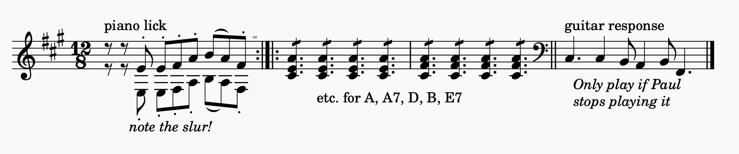
A | A | f#m | f#m (with vocals to fade)

